Student’s name Teacher’s name

________________________________________ _____________________________

2019
10 5.2 Course Semester 2 Examination

General Instructions  - Reading time – 2 minutes  - Working time –90 minutes  - Write using blue or black pen  Black pen is preferred  - Scientific calculators may be used | Total Marks – 60  - Questions arranged in topics. Attempt questions from all topics.

Section | 1 | 2 | 3 | 4 | Total
 | $$\frac{}{24}$$ | $$\frac{}{12}$$ | $$\frac{}{36}$$ | $$\frac{}{23}$$

Student Comment:

Teacher Comment:
Linear and Non Linear Relationships
24 marks
Attempt all Questions
Questions 1 to 4 Multiple choice
Allow about 15 - 20 minutes for this section

Circle the correct answer for Questions 1 to 5

Questions 1-2 refer to the diagram below

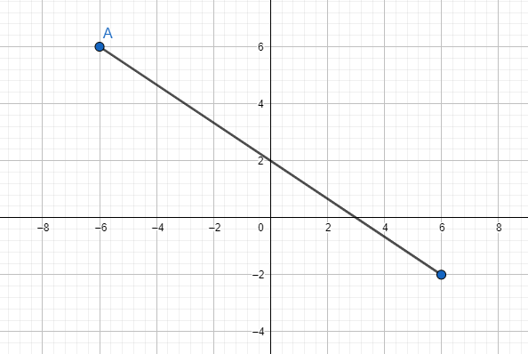
B

1. | The gradient of interval AB is:
 | (A) $\frac{4}{6}$ |  | (B) 2 |  | (C) $-\frac{2}{3}$ |  | (D) $\frac{2}{3}$
D4

2. | The mid-point of interval AB is:
 | (A) (0 , 2) |  | (B) (-1 , 3) |  | (C) (2, 0) |  | (D) (4 , - 6)
D4

3. | Line EF has a gradient of $4$. Line CD is perpendicular to line EF. The gradient of line CD is:
 | (A) $4$ |  |  | (B) $-\frac{1}{4}$ |  | (C) $\frac{1}{4}$ |  | (D) - 4
C5
4. | Which one of the following lines does the point (-1, 5) lie on?
C6 | (A) $y=3x+4$ |  |  |  | (B) $y=4x+9$
 | (C) $y=3x-2$ |  |  |  | (D) $y=-2x$
Questions 5-8 Short Answer. Show all working. Marks are as shown

5.  C5 |  | Parts a, b, and c refer to the graph shown below.  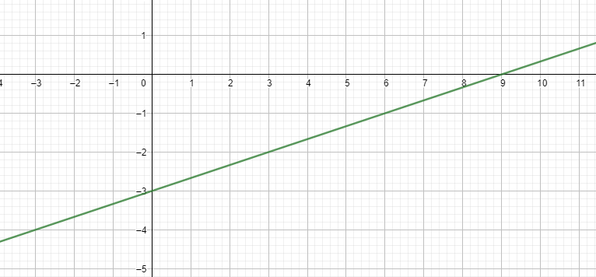 |  |  |  |  |  |  |  | Marks
C5 | a. | Determine the gradient of the line |  |  |  |  |  |  |  | 1
C5 | b. | Find the y-intercept of the line |  |  |  |  |  |  |  | 1
C5 | c. | Write the equation of the line in the form y = mx + b |  |  |  |  |  |  |  | 2
6. |  |  |  |  |  |  |  |  |  | Marks
C5 | a. | A line has the equation $y= \frac{2}{3}x – 6$. What is the gradient of a line parallel to this line? |  |  |  |  |  |  |  | 1
C6 | b. | Write the equation of the line that has the same y-intercept as the line $y= 3x + 8$ , and is parallel to the line $y=- \frac{3}{4}x+9$ |  |  |  |  |  |  |  | 2
C6 | c. | What is the equation of a line perpendicular to the line $y= -\frac{3}{2}x + 3$that goes through the point (1, 4) |  |  |  |  |  |  |  | 3
7. | Sketch the graphs given in parts a to c in the axes below  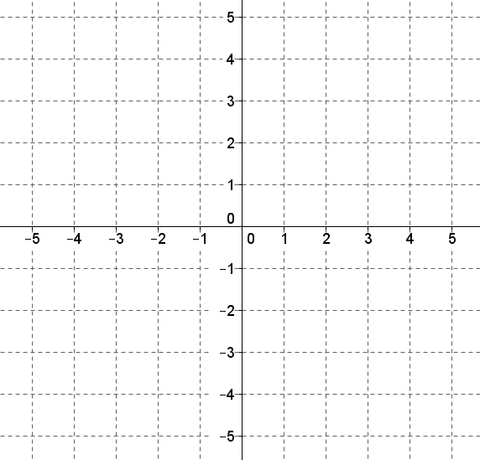 |  |  |  |  |  |  |  | Marks
D4 | a. | $$y=3$$ |  |  |  |  |  |  | 1
D4 | b. | $$y= 3-2x$$ |  |  |  |  |  |  | 2
D4 | c. | $$y= \frac{1}{2}x-2$$ |  |  |  |  |  |  | 2
8. |  | Use the length unit conversion graph to answer questions.  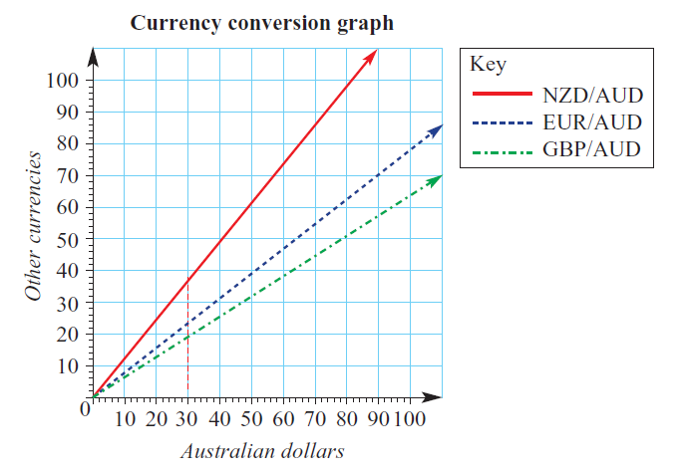
C5 | a. | Convert 90 AUD to EUR and use these values to find the gradient of the line, to 2 decimal places. |  |  |  |  |  |  | 2
B7 | b. | Use your previous answer to find the constant of proportionality k and write the direct proportion equation between EUR (y) and AUD (x). |  |  |  |  |  |  | 1
C6 | c. | Use the equation to convert 50 EUR to AUD. |  |  |  |  |  |  | 2

Right- Angled Triangles

12 marks
Attempt all Questions
Questions 9 to 12 Multiple choice
Allow about 15-20 minutes for this section

Circle the correct answer for Questions 9 to 12

9.  E2 |  | 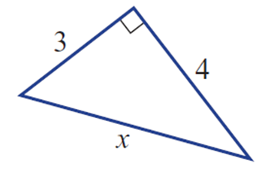  The correct working out to calculate the side x in the triangle shown below is:
 |  | - $x=\sqrt{\left({12}^{2}- 13^{2}\right)}$ |  |  |  |  | - $x=\sqrt{\left({12}^{2}+ {13}^{2}\right)}$
 |  | - $x=\sqrt{\left({13}^{2}- 12^{2}\right)}$ |  |  |  |  | - $x={13}^{2}- 12^{2}$
10.  D3 |  | In the triangle below the ratio cosθ is given by:  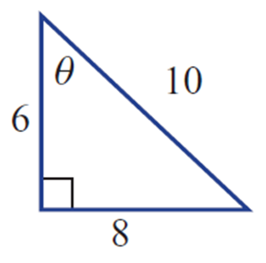
 |  | (A) $\frac{3}{5}$ |  |  | (B) $\frac{3}{4}$ |  | (C) $\frac{4}{5}$ |  | (D) $\frac{5}{4}$
11.  D4 |  | A measurement of an angle is found to be 72°29′35″. What is this measurement rounded to the nearest degree?
 |  | (A) 70º |  |  | (B) 72º |  | (C) 73º |  | (D) 72°30′
12.  D4 |  | What is the length of the side marked x?  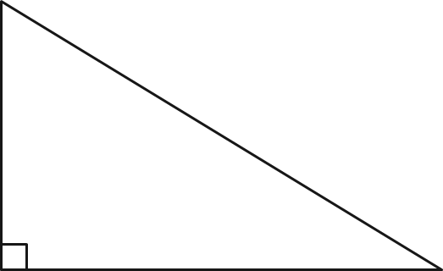  16cm  x  20cm
 |  | (A) 26cm |  |  | (B) 25cm |  | (C) 144cm |  | (D) 12cm
Questions 13-14 Short Answer. Show all working. Marks are as shown

13. |  |  |  | Find the side length x in these right-angled triangles. |  |  |  |  |  |  | Marks
D4 |  | a. |  | 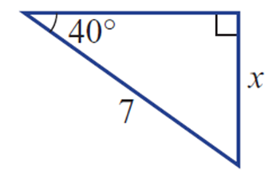 |  |  |  |  |  |  | 2
D4 |  | b. |  | 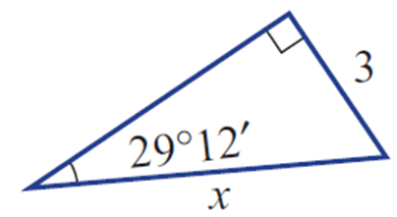  $$17°35'$$  x  9 |  |  |  |  |  |  | 2
14 |  |  |  | Find the missing angle θ in these right-angled triangles, to the nearest minute |  |  |  |  |  |  | Marks
D4 |  | a. |  |   x  $$26°$$  12cm |  |  |  |  |  |  | 2
D4 |  | b. |  |   x  26m  $$35°25'$$ |  |  |  |  |  |  | 2
Probability
36 marks
Attempt all Questions
Questions 15 to 18 Multiple choice
Allow about 15- 20 minutes for this section

Circle the correct answer for Questions 15 to 18

15.  D3 | In the following Venn Diagram P(A or B) is:  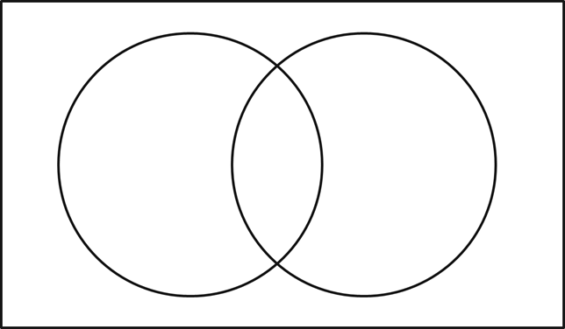  B  A  5  7  13  15
 | (A) 7/40 |  |  |  |  | (B) 28/40 |  | (C) 35/40 |  | (D) 5/40
16.  D3 | In the following two-way table, find the number of elements in ‘not A or B’.  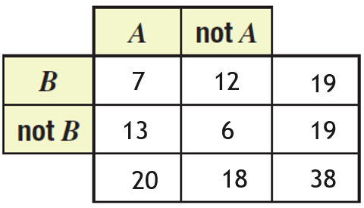
 | (A) $6$ |  |  |  |  | (B) $7$ |  | (C) $37$ |  | (D) $38$
17.  D4 | Number of heads 0 1 2 3  Frequency 6 16 23 5  An experiment involves tossing three coins and counting the number of heads.  What is the experimental probability of obtaining exactly 1 head?
 | (A) 16 |  |  |  |  | (B) 44 |  | (C) 16/50 |  | (D) 44/50
18.  B7 | In the following Venn Diagram P(B | A) (the probability of event B occurring given that event A has occurred) is:    B  A  5  7  13  15
 | (A) 7/15 |  |  |  |  | (B) 7/13 |  | (C) 7/22 |  | (D) 7/20
Questions 19-23 Short Answer. Show all working. Marks are as shown

19. |  |  | A bag contains 5 silver coins and 4 gold coins. Two coins are chosen with replacement.  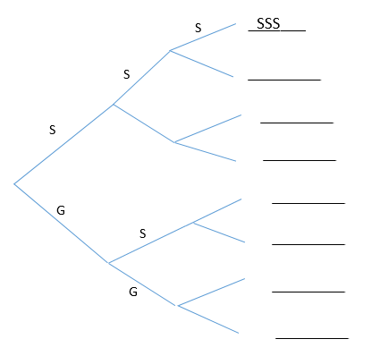  ___________  $$\frac{6}{10}$$  ___________  ___________  ___________ |  |  |  |  |  |  |  |  |  | Marks
C6 | a. |  | Complete the tree diagram above and list the sample space. |  |  |  |  |  |  |  |  |  | 4
C6 | b. |  | What’s the probability of obtaining at least 1 silver coin? |  |  |  |  |  |  |  |  |  | 3
C6 | c. |  | What’s the probability of obtaining exactly 1 gold coin? |  |  |  |  |  |  |  |  |  | 2
20. |  |  |   The Venn diagram shows the distribution of elements in two sets, A and B.  B  A  7  9  12  15 |  |  |  |  |  |  |  |  |  | Marks
D4 | a. |  | Transfer the information in the Venn diagram to a two-way table |  |  |  |  |  |  |  |  |  | 9
D3 | b. |  | Find the number of elements in A and B. |  |  |  |  |  |  |  |  |  | 2
D4 | c. |  | Find P(A or B). |  |  |  |  |  |  |  |  |  | 2
21. |  |  | A bakery sells 3 flavour doughnuts: plain (P), strawberry (S), and chocolate (C). Steph is in a hurry and randomly selects 2 different flavoured doughnuts. |  |  |  |  |  |  |  |  | Marks
C6 | a |  | Complete this table showing the possible combinations of doughnuts selected  P S C  P S C X (S,P) (C,P) |  |  |  |  |  |  |  |  | 2
C6 | b |  | Find the probability that Steph selects a chocolate doughnut. |  |  |  |  |  |  |  |  | 2
22 | Given that a number greater than 4 has been rolled on a fair six-sided die:
B7 | a List the sample space. |  |  |  |  |  |  |  |  |  |  | 1
B7 | b Calculate the probability that this number was 5. |  |  |  |  |  |  |  |  |  |  | 2
B7 | c Calculate the probability that this number was 4. |  |  |  |  |  |  |  |  |  |  | 1
23 | Explain why if you toss a 3 on a six sided die, the probability of obtaining a 3 on the second toss remains the same. |  |  |  |  |  |  |  |  |  |  | 2
B7

Statistics
23 marks
Attempt all Questions
Questions 24 to 27 Multiple choice
Allow about 15- 20 minutes for this section

Circle the correct answer for Questions 24 to 27

24.  E2 | What type of data would the following question generate?  “How many people in your family have a job?”
 | - Categorical –  Nominal |  |  |  |  | - Numerical –  Continuous |  | (C) Numerical – Discrete |  | (D) Categorical –  Ordinal
25.  D3 | The results of a mathematics exam are given below. Calculate the mean.  35 81 46 82 89 96 65 69 75 62
 | (A) $66$ |  |  |  |  | (B) $68$ |  | (C) $70$ |  | (D) $72$
26.  D3 | What is the median of the following set of data?  18 12 12 9 5 13 14 21 15
 | (A) $5$ |  |  |  |  | (B) $12$ |  | (C) $13$ |  | (D) $21$
27.  C5 | What is the maximum value, as represented in this box plot?  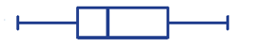  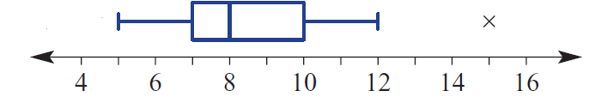
 | (A) $10$ |  |  |  |  | (B) $12$ |  | (C) $14$ |  | (D)$16$
Questions 28-30 Short Answer. Show all working. Marks are as shown

28. |  |  | The amount of points scored each game by 2 NRL teams are recorded below:  Roosters 14 14 30 10 22 34 42 22  Raiders 8 16 12 20 15 14 22 18 |  |  |  |  |  |  |  |  |  | Marks
D3 | a. |  | Calculate the mean, median and range for each team. |  |  |  |  |  |  |  |  |  | 6
D4 | b. |  | Which team achieved the better scores overall and justify your answer.  Use your results from part (a). |  |  |  |  |  |  |  |  |  | 2
D4 | c. |  | Represent this data in a back-to-back stem-and-leaf plot.  Roosters 14 14 30 10 22 34 42 22  Raiders 8 16 12 20 15 14 22 18 |  |  |  |  |  |  |  |  |  | 3
29.  C6 |  |  | Describe the correlation between the 2 variables in the following scatter plot.  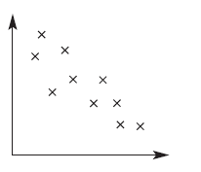 |  |  |  |  |  |  |  |  |  | Marks  2
30. |  |  | This time-series plot shows the trend good news on employment over a period of time.  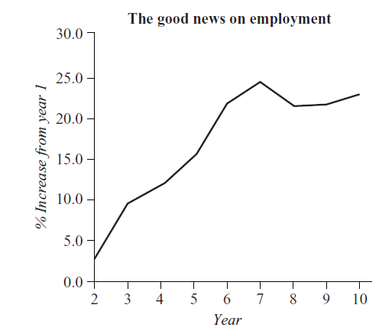 |  |  |  |  |  |  |  |  | Marks
C6 | a |  | Describe the general trend in good news on employment over this time period. |  |  |  |  |  |  |  |  | 2
C6 | b |  | After what year did we see the good news on employment drop for the first time in this time period? |  |  |  |  |  |  |  |  | 2
C6 | c |  | By the 5th year what was the percentage increase? |  |  |  |  |  |  |  |  | 2

END OF EXAM

